LEO’S  
MARCH CATALOG 2025

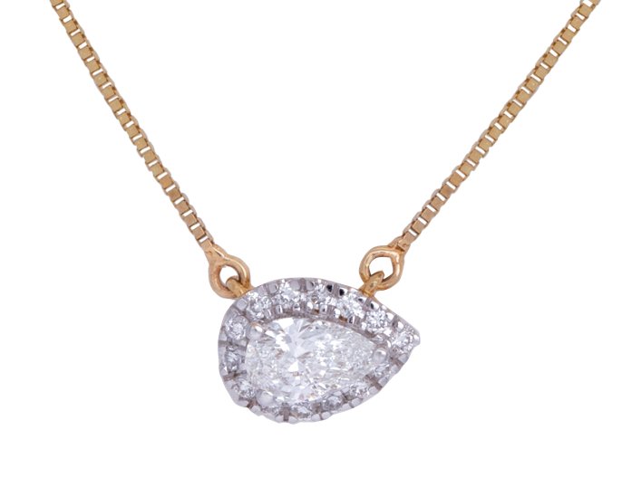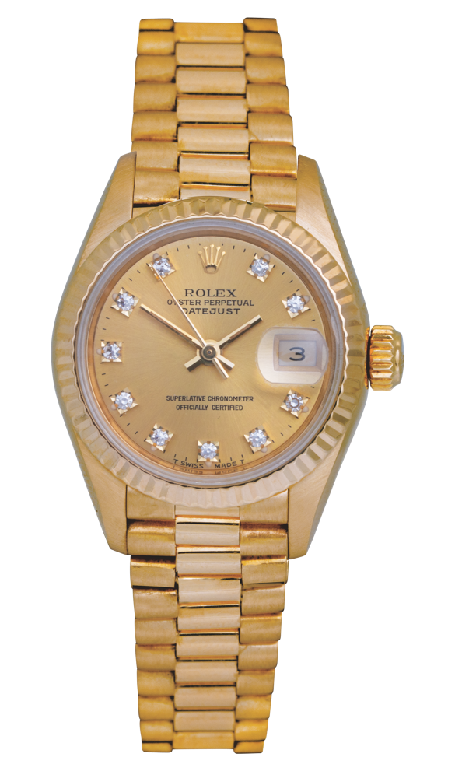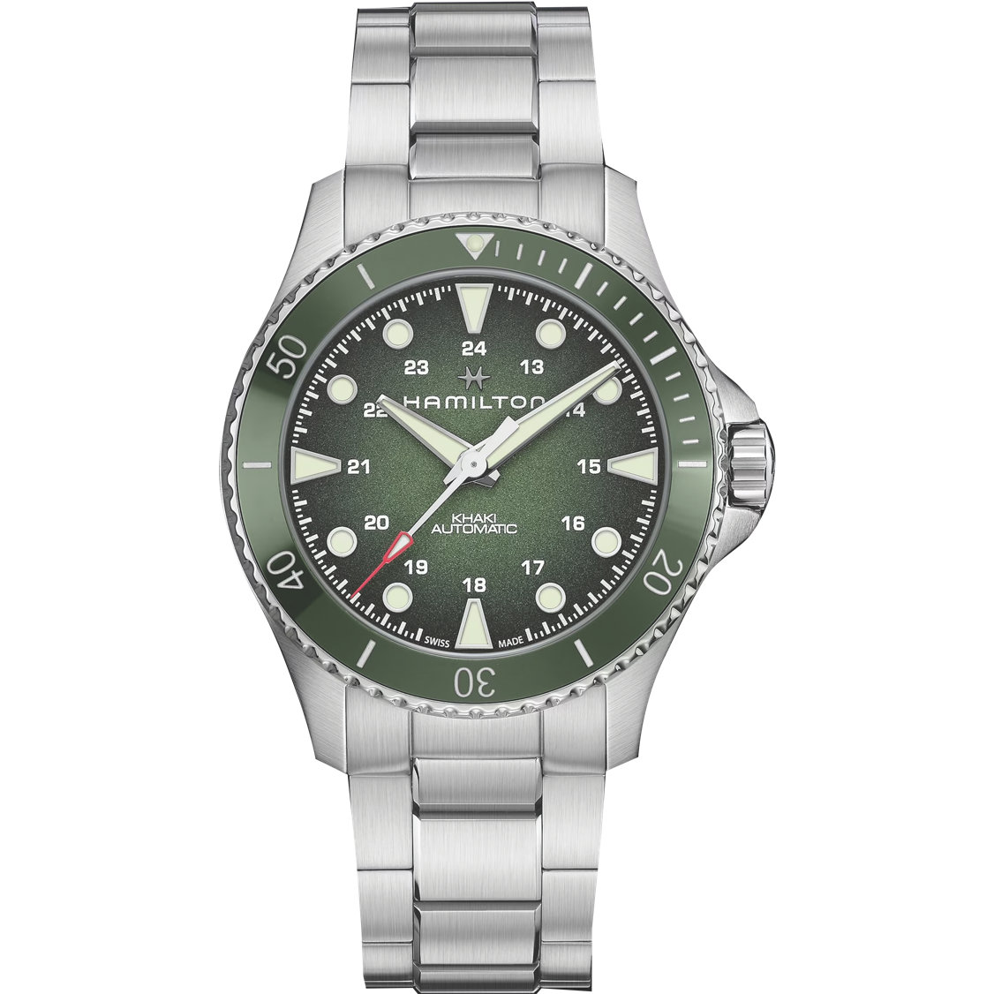

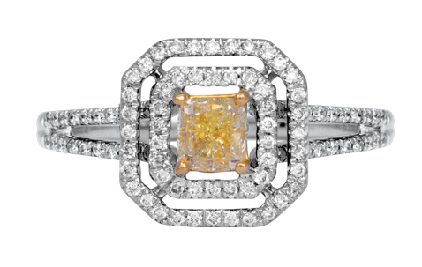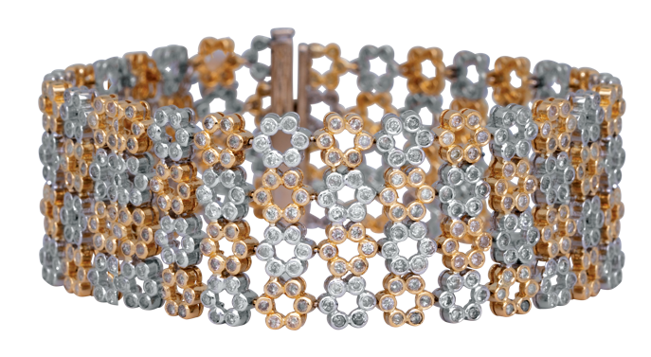

**619.299.1500 www.leohamel.com**

**Lab-Grown Diamond Jewelry**

|  |  |  |  |
| --- | --- | --- | --- |
| A silver necklace with diamonds  #23655  New 14k white gold circle pendant set with 0.40 carats of lab-grown diamonds.  Retail Price: $1,225, **Our Price: $1,150** | A pair of gold and diamond earrings  #23329  New 14k yellow gold drop earrings set with 1.50 carats of lab-grown diamonds.  Retail Price: $2, 350 **Our Price: $2,150** | **A pair of diamond earrings**  #24676  New 14k yellow gold halo earrings set with  2.04 carats of lab-grown diamonds.  Retail Price: $1,995,  **Our Price: $1,695** | A close up of a diamond necklace    #23658  New 14k yellow gold halo pendant set with 0.25 carats of lab-grown diamonds.  Retail Price: $675,   **Our Price: $575** |

**GOLD IS UP!**

**Get Paid the most for your Valuables**Gold prices are on the rise again! This could be a good time to cash in and get the   
most money for your gold coins, bullion, or jewelry. And selling gold is easy with   
Leo's Professional Gold Buyers!

**WE BUY!**Jewelry, Diamonds, Watches, Coins,   
Handbags and more!

|  |  |  |  |
| --- | --- | --- | --- |
| San Diego 1851 San Diego Ave 619.299.1500 | La Mesa 8911 La Mesa Blvd 619.644.0000 | Solana Beach 921 Lomas Santa Fe 858.509.5900 | Oceanside 2530 Vista Way #H 760.757.2000 |

**Engagement & Wedding Rings**

|  |  |  |
| --- | --- | --- |
| A close up of a ring  #10480  New 14k white gold eternity band set with 2.60 carats of  lab-grown diamonds.  Retail Price: $3,175,  **Our Price: $2,750** | A diamond ring with a black background  #21024  New 14k white gold engagement ring set with a 1.50 carat lab-grown diamond and a 1.00 carat lab-grown diamond under-halo.  Retail Price: $2,425,   **Our Price: $2,125** | **A close up of a ring**  #23606  Custom new 14k yellow gold crossover ring set with a  1.71 carat lab-grown diamond.  Retail Price: $4,500,  **Our Price: $3,500** |
| A diamond ring with a black background  #23431  Vintage 18k white gold Michael M engagement ring set with a 2.58 carat diamond and a  1.80 carat diamond halo.  Retail Price: $26,325,  **Our Price: $17,900** | A close up of a ring  #12294  Vintage 14k white gold engagement ring set with a 1.02 carat diamond flanked by 0.50 carats of diamonds.  Retail Price: $6,300,  **Our Price: $3,150** | A diamond ring with a yellow square center  #23088  Vintage 18k white & yellow gold engagement ring set with a 0.56 carat diamond and a 0.29 carat diamond double halo.  Retail Price: $4,250,  **Our Price: $3,295** |
| A close-up of a diamond ring  #24844  New 18k white gold engagement ring set with a 4.02 carat lab-grown diamond flanked by 0.98 carats of diamond.  Retail Price: $10,375,  **Our Price: $8,900** | **A close up of a ring**  #24848  New 18k white gold engagement ring set with a  4.19 carat lab-grown diamond flanked by 1.01 carats of  lab-grown diamonds.  Retail Price: $10,795,  **Our Price: $9,195** | A close up of a ring    #22357  Vintage platinum engagement ring set with a 1.00 carat diamond surrounded by  0.32 carats of diamonds.  Retail Price: $9,400,  **Our Price: $7,350** |

LEGEND  
k - karat

**Vintage Jewelry**

|  |  |  |
| --- | --- | --- |
| A close up of a bracelet  #23999  Vintage 18k white & yellow gold flower bracelet set with 8.43 carats of diamonds.  Retail Price: $16,000,  **Our Price: $11,995** | A gold ring with diamonds and pearls  #24199  Vintage 14k rose gold Kabana swirl ring inlaid with mother-of-pearl and 0.20 carats of diamonds.  Retail Price: $1,250,  **Our Price: $795** | A silver and pink star necklace  #23845  Vintage 18k white & rose gold  star lariat necklace set with  0.80 carats of diamonds.  Retail Price: $5,000,  **Our Price: $2,995** |
| A gold moon and star necklace  #24111  Vintage 18k yellow gold star & crescent moon pendant set with 0.03 carats of diamonds.  Retail Price: $700,  **Our Price: $550** | A close up of a ring  #23639  Vintage 18k yellow gold cluster ring set with turquoise cabochons.  Retail Price: $1,300,  **Our Price: $1,095** | A ring with a diamond in the center  #23163  Vintage 18k white & yellow gold starburst ring set with 0.56 carats of diamonds.  Retail Price: $3,000,  **Our Price: $2,500** |
| A silver horseshoe with diamonds on a chain  #23515  Vintage 18k white gold horseshoe pendant set with 1.40 carats of diamonds.  Retail Price: $3,300,  **Our Price: $2,400** | A pair of gold earrings with blue and white stones  #22716  Vintage 18k yellow gold hoop earrings set with 1.00 carat of sapphires & 0.50 carats of diamonds.  Retail Price: $3,150,  **Our Price: $2,200** | A pair of diamond earrings  #23503  Vintage 18k white gold drop earrings set with 0.75 carats of diamonds.  Retail Price: $1,500,  **Our Price: $1,250** |

LEGEND  
k - karat

**Vintage Designer & Handbags**

|  |  |  |
| --- | --- | --- |
| A brown louis vuitton handbag  #24654  Vintage brown leather Louis Vuitton *Monogram Speedy Nano* handbag.  Retail Price: $1,800,  **Our Price: $995** | A white quilted bag with gold chains  #23591  Vintage white Caviar leather Chanel *Classic Double Flap* handbag.  Retail Price: $11,700,  **Our Price: $6,900** | A close-up of a bowl  #24207  Vintage sterling silver John Hardy *Kali Dot* bangle bracelet.  Retail Price: $995,  **Our Price: $495** |
| A close up of rings  #23478  Vintage 18k yellow, white, and rose gold Cartier *Trinity* ring.  Retail Price: $3,500,  **Our Price: $2,700** | A gold ring with diamonds  #24179 Vintage 18k yellow gold Tiffany & Co. *T Wire* band set with 0.13 carats of diamonds.  Retail Price: $2,675,  **Our Price: $1,695** | A gold necklace with a infinity symbol on it  #24283  Vintage 18k rose gold Tiffany & Co. *Infinity* 20” double strand necklace.  Retail Price: $1,500,  **Our Price: $950** |
| A close up of a ring  #24208  Vintage sterling silver David Yurman *Confetti* band set with 0.21 carats of diamonds.  Retail Price: $825,  **Our Price: $395** | A pair of gold earrings with a chanel logo  #24422  Vintage gold tone Chanel *CC* clip-on earrings.  Retail Price: $750,  **Our Price: $595** |  |

LEGEND  
k - karat

**Special Deals!   
40-60%OFF**

|  |  |  |
| --- | --- | --- |
| A gold necklace with a flower and diamonds  #15931  Vintage 18k yellow gold clover necklace set with 0.10 carats of diamonds.  Retail Price: $1,900,  **Our Price: $1,140** | A close-up of a silver chain  #10764  Vintage 18k white gold Tacori *Crescent Silhouette* bracelet set with 1.00 carats of diamonds.  Retail Price: $7,500,  **Our Price: $3,000** | A close-up of a necklace  #99914356  Vintage 14k white gold slide pendant set with 0.42 carats of diamonds.  Retail Price: $1,100,  **Our Price: $440** |
| A close up of a necklace  #99900500  Vintage 10k white gold teardrop pendant set with 0.53 carats of diamonds.  Retail Price: $700,  **Our Price: $350** | A gold and blue bracelet with diamonds and gems  #16967  Vintage 18k yellow gold bangle bracelet set with  1.30 carats of sapphires &  1.20 carats of diamonds.  Retail Price: $6,700,  **Our Price: $3,350** | A diamond ring with a black background  #15114  Vintage 18k white gold cluster ring set with 2.70 carats of diamonds.  Retail Price: $4,395,  **Our Price: $2,637** |
| A silver star ring with diamonds  #10552  New 14k white gold  three-star ring set with 0.35 carats of diamonds.  Retail Price: $1,475,  **Our Price: $737.50** | A gold ring with a red stone and diamonds  #22545  Vintage 18k yellow gold Ansuini ring set with a 3.55 carat cabochon ruby flanked by 0.40 carats of diamonds.  Retail Price: $5,250,  **Our Price: $2,625** | A pair of earrings with pearls and diamonds  #99915543  Vintage 14k yellow gold earrings set with 9mm Akoya pearls and a  1.12 carat diamond halo.  Retail Price: $2,995,  **Our Price: $1,196** |

LEGEND  
k - karat

**New & Pre-owned Watches**

|  |  |  |
| --- | --- | --- |
| A close-up of a watch  #22906  Pre-owned Rolex *Datejust President* watch with a champagne diamond dial. 26mm. 18KY, A, C, F, Pr.  Retail Price: $30,200,  **Our Price: $10,500** | A close up of a watch  #24587  Pre-owned Breitling *Navitimer* watch with a pink mother-of-pearl diamond dial. SS, B, C, F, Q.  Retail Price: $4,800,  **Our Price: $3,195** | A close up of a watch  #24706  New Tissot *PR516 Powermatic 80* watch with a blue dial. 38mm.  SS, A, B, C, L, T.  **Price: $650** |
| A silver watch with black leather straps    #24784  New Hamilton *Khaki Field Murph* watch with an exhibition case back. 38mm. A, B, C, R, T.  **Price: $895** | A close up of a watch  #24705  New Tissot *Seastar 1000 GMT* watch with a black dial. 40mm. SS & gold PVD , B, C, F, Q.  **Price: $550** | A silver watch with orange numbers  #99915461  Pre-owned Rolex *Milgauss* watch with a white dial. 40mm. SS, A, B, C, F, O.  Retail Price: $12,000,  Our Price: $9,750 |
| A close-up of a watch  #24782  New Hamilton *Khaki Navy Scuba* watch with a green dial. 43mm. SS, A, B, C, F.  Price: $1,075 | #23669  Pre-owned Breitling *Bentley Chrono* watch with a silver dial. 48mm. 18KY, A, B, C, L, T.  Retail Price: $28,580,  Our Price: $16,950 | **A close up of a watch** |

Legend

18KY – 18k yellow gold

A – automatic movement

B – box and/or papers

C – sapphire crystal

F – folding clasp

L – leather bracelet

O – Oyster bracelet

Pr – President bracelet

PVD – physical vapor deposition

Q – quartz movement

R – rubber strap

SS – stainless steel

T – tang buckl

**Extraordinary Jewelry**

|  |  |  |
| --- | --- | --- |
| A silver and diamond hair clip  #24922  New 18k white gold Hearts On Fire *Triplicity* ring set with 2.57 carats of diamonds.  Retail Price: $11,995,  **Our Price: $9,395** | **A close-up of a black background**  #20298  Vintage 18k white gold marquise & cross bracelet set with 7.00 carats of diamonds.  Retail Price: $15,000,  **Our Price: $11,500** | **A close-up of a necklace**  #24875  Vintage 19.5” necklace strung with 10-11.9mm Tahitian pearls on an 18k white gold clasp set with  1.00 carat of diamonds.  Retail Price: $11,500,  **Our Price: $7,800** |