LEO’S  
FEBRUARY CATALOG 2025

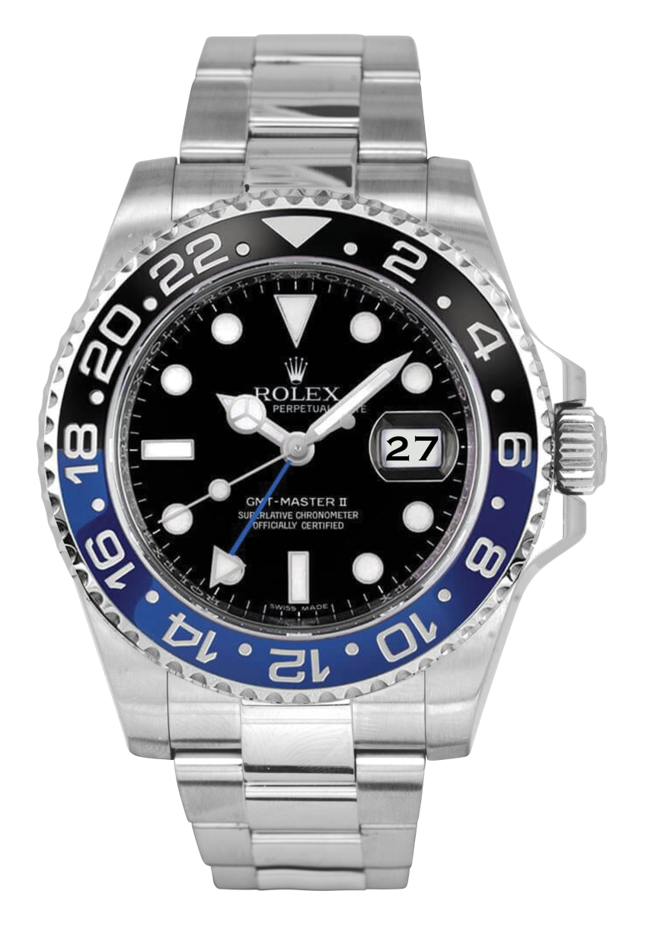

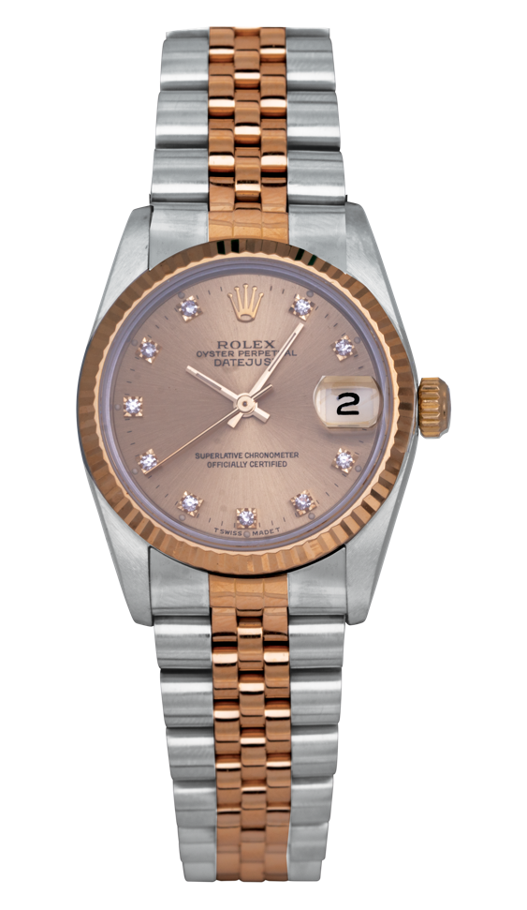

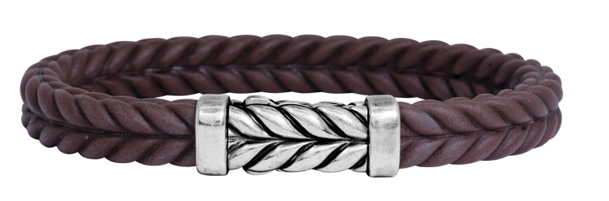

**619.299.1500 www.leohamel.com**

**Gifts For Him**

|  |  |  |
| --- | --- | --- |
| A close up of a bracelet  #20914  Vintage men’s sterling silver & brown rubber David Yurman Chevron bracelet.  Retail Price: $450  **Our Price: $315** | A pair of silver cuff links  #21372  Vintage sterling silver  Jan Leslie *Rivet Etch* cuff links set with black onyx.  Retail Price: $695  **Our Price: $350** | A gold ring with a diamond in the middle  #22885  Vintage 18k yellow gold wedding band set with a 0.15 carat princess diamond.  Retail Price: $2,875  **Our Price: $2,250** |
| carbon watch  #24018  New men’s Tissot *PRX  Powermatic 80* with black  carbon case. A, B, C, R, T.  **Price: $995** | A gold chain on a black background  #23736  Vintage 14k yellow gold  Figaro link necklace.  Retail Price: $2,250  **Our Price: $1,850** | LEGEND  k – karat A - automatic movement  B - box and/or papers  C - sapphire crystal  R - rubber strap  T - tang buckle |

**Special Financing Available\*\***

No Interest if Paid in Full Within 12 Months!*

***Shop now and take a year to pay.***Got your eye on something special but don’t want to spend the cash right now?   
Apply for our no-interest financing, pay over 12 months, and take it home today!

*Quick in-store credit*

*Ability to purchase more today*

*No annual or promotional fees*

*Reserve general purpose credit cards for everyday purchases or unplanned expenses*

*Easy-to-use online bill payment option*

*Interest will be charged to your account from the purchase date if the purchase balance is   
not paid in full within the promotional period.*\*\*Subject to credit approval.*

Terms and Conditions

**\*\*The Wells Fargo Jewelry Advantage credit card is issued by Wells Fargo Bank, N.A. The special terms APR will continue to apply until all qualifying purchases are paid in full. The   
monthly payment for this purchase will be the amount that will pay for the purchase in full in equal payments during the promotional (special terms) period. The APR for Purchases will apply to certain fees such as a late payment fee or if you use the card for other transactions. For new accounts, the APR for Purchases is 28.99%. If you are charged interest in any billing cycle, the minimum interest charge will be $1.00. This information is accurate as of 01/01/2025 and is subject to change. Offer expires 02/15/2025.**

**Engagement & Lab-Grown**

|  |  |  |
| --- | --- | --- |
| A close up of a diamond ring  #24164  New 14k white gold halo engagement ring centered with a 1.83 carat  lab-grown diamond surrounded by  0.15 carats of lab-grown diamonds.  Retail Price: $3,500  **Our Price: $3,000** | **A diamond ring with a yellow heart**  #23492  Vintage platinum ring set with a  2.01 carat fancy yellow heart diamond and a 1.33 carat diamond double halo.  Retail Price: $19,500  **Our Price: $13,995** | **A close-up of a diamond ring**  #20111  New 14k white gold wedding band set with a 1.50 carat lab-grown Asscher diamond.  Retail Price: $2,975  **Our Price: $2,575** |
| **A silver ring with black square and diamonds**  #23164  Vintage 18k white gold elongated ring set with 0.90 carats of diamonds.  Retail Price: $3,500  **Our Price: $2,895** | A close up of a ring  #22536  Vintage platinum halo engagement  ring set with a 2.01 carat princess diamond and a 0.75 carat diamond halo.  Retail Price: $23,450  **Our Price: $15,500** | **A close-up of a ring**  #13737  New 14k white gold *Toi et Moi* ring set with a 1.00 carat lab-grown diamond & a 1.00 carat  lab-grown ruby.  Retail Price: $2,195  **Our Price: $1,895** |
| A close-up of a ring  #24237  New 18k white gold oval link ring set with 0.31 carats of diamonds.  Retail Price: $1,925  **Our Price: $1,650** | A diamond ring with baguette stones  #23293  Vintage platinum Chatham ring  centered with a 5.68 carat lab-grown diamond flanked by 0.50 carats of  lab-grown diamonds.  Retail Price: $15,500  **Our Price: $11,500** | A diamond ring with a square cut diamond  #22786-15191  Vintage 14k white gold halo engagement ring centered with a  3.09 carat lab-grown diamond surrounded by a 0.42 carat  diamond halo.  **Retail Price: $3,875** |
| A close up of a ring  #12656  New 14k yellow gold band set with  2.24 carats of diamonds.  Retail Price: $5,995  **Our Price: $4,995** | A gold ring with diamonds  #23913  New 18k halo ring centered with a  0.70 rose-cut marquise diamond surrounded by a 0.37 carat  diamond halo.  **Retail Price: $3,875  Our Price: $3,275** | LEGEND  k - karat |

**Chatham Lab-Grown  
Diamond Jewelry**

|  |  |  |
| --- | --- | --- |
| A pair of earrings with a red gem  #24431  New 14k white gold Chatham earrings set with 3.60 carats of lab-grown rubies and lab-grown diamond haloes.  **Price: $2,095** | A pair of earrings with a red gem  #24432  New 14k white gold Chatham hoop earrings set with 2.45 carats of lab-grown flame-cut rubies & diamonds.  **Price: $2,625** | A necklace with a red rectangular pendant  #24433  New 14k white gold Chatham necklace set with a 3.28 carat lab-grown ruby and a  0.21 carat lab-grown diamond halo.  **Price: $2,295** |
| A pink gem on a silver band  #24430  New 14k white gold Chatham ring set with a 2.55 carat lab-grown pink sapphire and a  0.12 carat lab-grown diamond halo.  **Price: $2,095** | A close up of a ring  #23962  New 14k white gold Chatham halo ring centered with a  2.17 carat lab-grown century ruby and 0.18 carats of lab-grown diamonds.  **Price: $1,975** | A close up of a necklace  #23653  New 14k yellow gold pendant set with a  0.33 carat lab-grown diamond and a  0.09 carat lab-grown diamond halo.  Retail Price: $1,175  **Our Price: $995** |
| A close-up of a bracelet  #23650  New 14k white gold tennis bracelet set with 6.91 carats of lab-grown round & emerald-cut diamonds.  Retail Price: $7,225  **Our Price: $5,995** | A close-up of a necklace  #23654  New 14k white gold pendant set with a 0.99 carat lab-grown princess diamond.  Retail Price: $2,250  **Our Price: $1,950** | A pair of diamond earrings  23333  New 14k huggie hoop earrings set with  3.00 carats of lab-grown diamonds.  Retail Price: $2,225  **Our Price: $1,895** |
| #23597  New 14k white gold flower earrings set with0.75 carats of lab-grown diamonds.  Retail Price: $1,175,  **Our Price: $995** | A pair of diamond earrings | LEGEND  k - karat |

**Gifts for her under $500**

|  |  |  |
| --- | --- | --- |
| A pink purse with a gold button  #23994  Vintage pink monogram Louis Vuitton *Vernis* wallet with  dust bag.  Retail Price: $700  **Our Price: $325** | A silver bracelet with a heart and a toggle  #23454  Vintage sterling silver Tiffany & Co*. Please Return to Tiffany Heart Tag* bracelet.  Retail Price: $700  **Our Price: $425** | A silver key with a heart pendant on a chain  #23859 Vintage sterling silver Tiffany & Co. *Heart Mini Key* necklace.  Retail Price: $385  **Our Price: $250** |
| A necklace with a blue stone  #23643  Vintage 18k yellow gold & sterling silver Konstantino *Quatrefoil* pendant set with 3.35 carats of blue topaz.  Retail Price: $980  **Our Price: $450** | A pair of pink earrings  #22515  New 14k yellow gold Denny  Wong *Conch Shell* earrings.  Retail Price: $425  **Our Price: $350** | A close-up of a ring  #23039 Vintage sterling silver Lagos *Caviar* ring set with 0.10 carats of diamonds.  Retail Price: $600  **Our Price: $300** |
| A pair of gold hoop earrings  #23641  Vintage 14k yellow gold oval  twist hoop earrings.  Retail Price: $500  **Our Price: $395** | A pair of blue and white earrings  #22710  New 14k yellow gold Venetti earrings set with 0.28 carats of turquoise &  0.06 carats of diamond haloes.  Retail Price: $558 **Our Price: $475** | A pearl necklace on a chain  #19103  New Denny Wong freshwater  pearl necklace on a 14k white  gold clasp.  Retail Price: $575  **Our Price: $475** |

LEGEND  
k - karat

**Gifts for under $2500**

|  |  |  |
| --- | --- | --- |
| A pair of diamond earrings  #23602  Vintage 14k white gold earrings set with 0.50 carats of diamonds and 0.36 carats of diamond haloes.  Retail Price: $1,775  **Our Price: $1,450** | A pair of earrings with colored stones  #23917  New 18k white gold oval hoop earrings set with  1.12 carats of multicolored sapphires.  Retail Price: $1,925  **Our Price: $1,650** | A close-up of a ring  #23760  New 18k white gold eternity ring set with a 1.05 carat pink sapphire & 0.52 carats of diamonds in the halo & band.  Retail Price: $2,325  **Our Price: $1,975** |
| A pair of gold hoop earrings  #23673  Vintage 18k yellow gold hoop earrings with dangling coins.  Retail Price: $1,895  **Our Price: $1,550** | A diamond ring with a black background  #23912  New 18k white gold flower ring set with 0.92 carats of diamonds.  Retail Price: $2,625,  **Our Price: $2,250** | A gold and diamond heart necklace  #22712  New 14k yellow gold Venetti heart pendant set with 0.25 carats of diamonds.  Retail Price: $1,498  **Our Price: $1,300** |
| A silver heart necklace with diamonds  #19348  New 18k white gold open heart necklace set with 0.26 carats of diamonds.  Retail Price: $1,875  **Our Price: $1,600** | A close-up of a necklace  #24125  New 14k white gold flower pendant set with a 0.32 carat ruby and a 0.07 carat diamond halo.  Retail Price: $2,695  **Our Price: $2,295** | A gold chain with a diamond pendant  23878 New 18k yellow gold Hearts On Fire *Signature Petal* pendant set with  0.51 carats of diamonds.  Retail Price: $2,475  **Our Price: $1,890** |

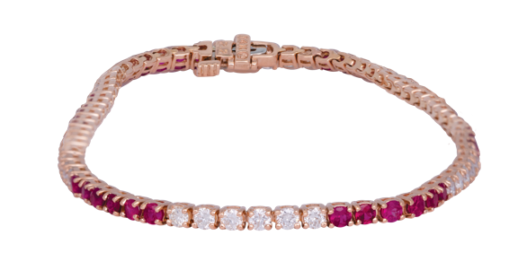

#23109 Vintage 14k rose gold tennis bracelet set with 2.56 carats   
of rubies & diamonds.  
Retail Price: $3,350, **Our Price: $2,350**

LEGEND  
k - karat

**New & Pre-owned Watches**

|  |  |  |
| --- | --- | --- |
| A close-up of a watch  #24141  Pre-owned women’s Rolex  *Datejust* watch with a diamond dial. 18KY & SS. A, C, F, J.  Retail Price: $13,300  **Our Price: $6,800** | A silver watch with a blue face  #23382  Pre-owned men’s Omega *Seamaster Aqua Terra* watch with an exhibition case. SS, A, C, F.  Retail Price: $6,300  **Our Price: $3,450** | A close up of a watch  #21313  Pre-owned men’s Cartier *Santos 100 XL* watch with white dial.  18KY, A, C, F.  Retail Price: $26,800  **Our Price: $16,800** |
| A close-up of a watch  #23867  Pre-owned men’s Rolex *GMT-Master II* watch with a “Batman” ceramic bezel. SS, A, B, C, F, O.  Retail Price: $17,000  **Our Price: $16,500** | A close-up of a watch  #23135  Pre-owned men’s Panerai *Luminor GMT* watch with a black dial.  SS, A, B, C, F, R.  Retail Price: $6,900  **Our Price: $4,395** | A silver watch with a green face  #14534  New men’s Tissot *PRX* watch with a green dial. SS, B, C, F, Q.  **Price: $395** |
| A close-up of a watch  #24136  Pre-owned men’s Breitling *Chrono Avenger* watch with a black dial. Ti, A, B, C, F.  Retail Price: $5,850  **Our Price: $3,250** | A close-up of a watch  #20510  New men’s Hamilton *Khaki Aviation X-Wind GMT* watch with a tachymeter bezel. SS, B, C, L, T, Q.  **Price: $1,045** |  |

LEGEND

SS – stainless steel | 18KY – 18k yellow gold

Ti – titanium

A – automatic movement

B – box and/or papers

C – sapphire crystal

J – Jubilee bracelet

L – leather bracelet

O – oyster bracelet

F – folding clasp

R – rubber strap

T – tang buckle

Q – quartz movement

**Extraordinary Valentine**

**Gifts**

|  |  |  |
| --- | --- | --- |
| **A close up of a ring**  #20437  New 18k white gold lattice band set with 3.16 carats of diamonds.  Retail Price: $9,995  **Our Price: $8,500** | **A close-up of a bracelet**  #23205  Vintage 18k white gold bracelet set with 17.48 carats of old European & single cut diamonds and rubies.  Retail Price: $68,000,  **Our Price: $52,500** | **A pair of diamond earrings**  #23900  New 18k white gold Hearts On Fire *Aurora* earrings set with 2.41 carats  of diamonds.  Retail Price: $13,300  **Our Price: $9,310** |