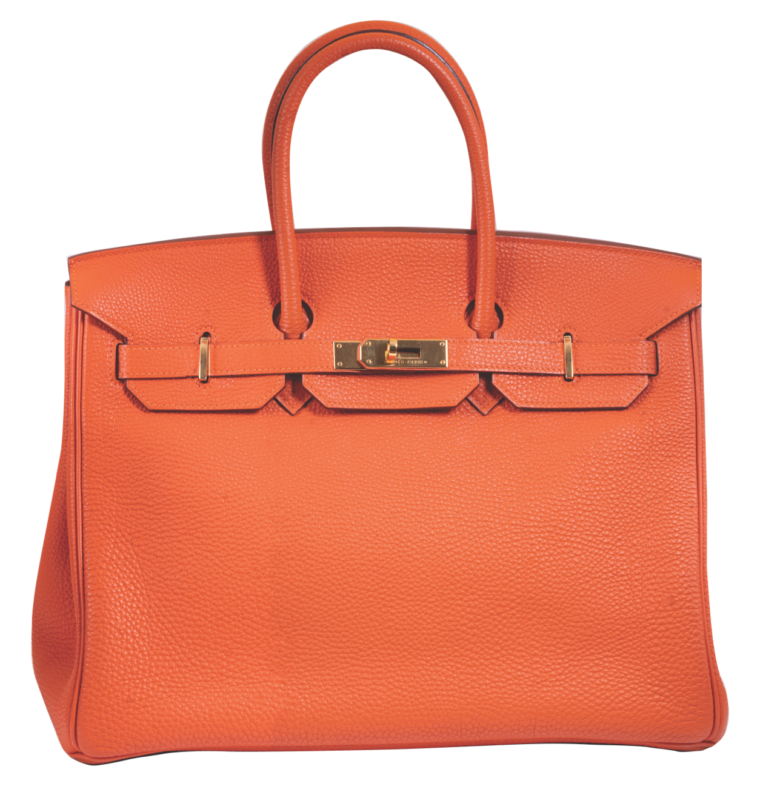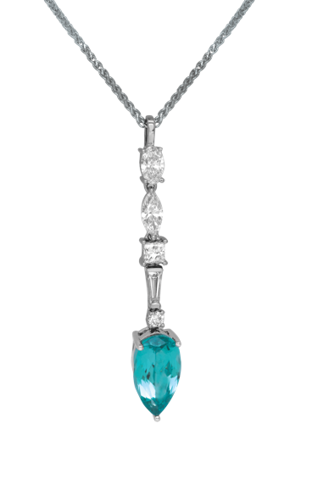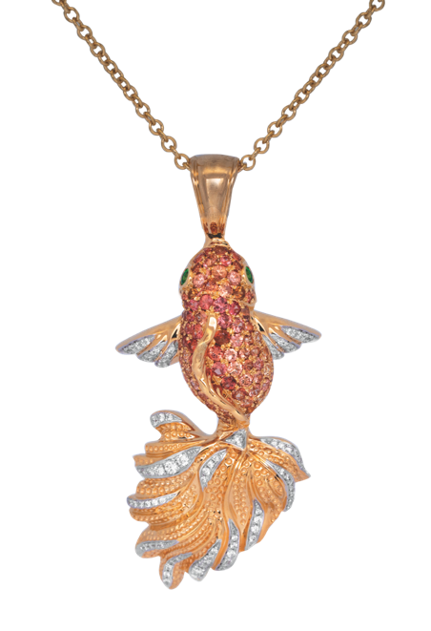LEO’S  
APRIL CATALOG 2025

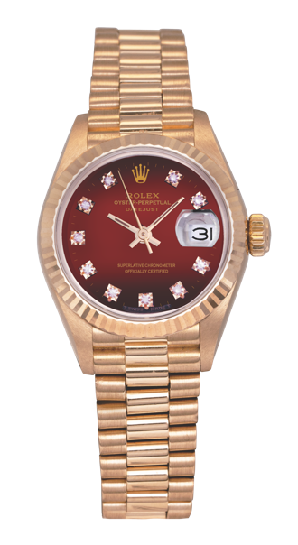

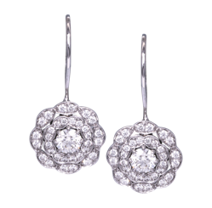

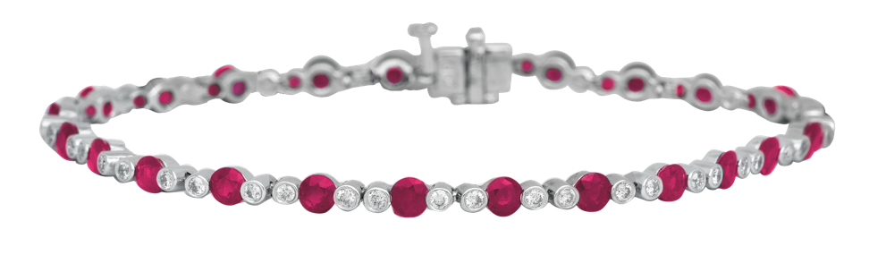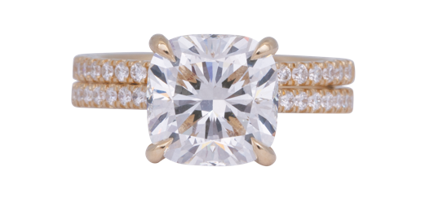

**619.299.1500 www.leohamel.com**

|  |  |  |  |
| --- | --- | --- | --- |
| **A gold necklace with diamonds**  #25718  New 14k yellow gold spike necklace set with 0.30 carats of diamonds.  Retail Price: $2,195,  **Our Price: $1,895** | A pair of diamond earrings  #23894  New 18k white gold Hearts On Fire *Lorelei* double halo drop earrings set with  0.73 carats of diamonds.  Retail Price: $5,225,  **Our Price: $3,750** | A gold ring with diamonds  #25604 New 18k rose gold Hearts On Fire *Triplicity* band set with 0.67 carats of diamonds.  Retail Price: $2,450,  **Our Price: $1,800** | A pair of gold earrings with diamonds  #24221  New 14k yellow gold cut out drop earrings set with 0.41 carats of diamonds.  Retail Price: $2,350,  **Our Price: $1,995** |

**Diamond Jewelry**

|  |  |
| --- | --- |
| **A silver ring with diamonds**  #25507  New 18k white gold Hearts On Fire *White Kites Bird* bangle bracelet set with 0.84 carats of diamonds.  Retail Price: $5,700,  **Our Price: $4,095** | **A close-up of a necklace**  #25505  New 18k white gold  Hearts On Fire *Liliana* bar necklace set with 0.17 carats of diamonds.  Retail Price: $1,275,  **Our Price: $950** |

**GOLD IS UP!**

**Get Paid the most for your Valuables!**Gold prices are on the rise again! This could be a good time to cash in and get the   
most money for your gold coins, bullion, or jewelry. And selling gold is easy with   
Leo's Professional Gold Buyers!

**WE BUY!**Jewelry, Diamonds, Watches, Coins,   
Handbags and more!

|  |  |  |  |
| --- | --- | --- | --- |
| San Diego 1851 San Diego Ave 619.299.1500 | La Mesa 8911 La Mesa Blvd 619.644.0000 | Solana Beach 921 Lomas Santa Fe 858.509.5900 | Oceanside 2530 Vista Way #H 760.757.2000 |

LEGEND  
k - karat

**New Colored Gemstone Jewelry**

|  |  |  |
| --- | --- | --- |
| A gold ring with a blue stone  #24905  Vintage 18k yellow gold ring set with 3.30 carat aquamarine & 0.20 carats of diamonds.  Retail Price: $3,750,  **Our Price: $2,850** | **A gold ring with a red stone and emeralds**  #16768  New 18k yellow gold Judy Mayfield *Shell* ring set with a 2.85 carat rubellite tourmaline, 0.27 carats of Paraíba tourmalines, and 0.30 carats of diamonds.  Retail Price: $12,473,  **Our Price: $8,700** | **A blue square gem on a gold ring**  #24769  Vintage 14k rose gold ring set with a 10.90 carat Swiss blue topaz & 3.50 carats of pink tourmaline.  Retail Price: $3,650,  **Our Price: $2,650** |
| A gold ring with diamonds and rubyA gold ring with diamonds and ruby  #22544  Vintage 18k yellow gold tapered hoop earrings set with 2.88 carats of rubies & 1.75 carats of diamonds.  Retail Price: $6,875,  **Our Price: $5,675** | A close up of a ring  #24491  New 18k white gold  2-row band set with 0.64 carats of sapphires & 0.20 carats of diamonds.  Retail Price: $3,625,  **Our Price: $3,095** | A close-up of a bracelet  #22555  Vintage 14k white gold tennis bracelet set with 5.25 carats of rubies & diamonds.  Retail Price: $3,875,  **Our Price: $3,075** |
| A gold and pink pendant on a chain  #25390  New 18k yellow gold Judy Mayfield *Koi* *Fish* enhancer pendant set with 2.27 carats of orange sapphires  Retail Price: $14,400,  **Our Price: $11,500** | A close-up of a necklace  #25342  New 18k white gold pendant centered with a 0.16 carat emerald surrounded by a  0.16 diamond halo.  Retail Price: $1,750,  **Our Price: $1,550** | A pair of earrings with blue stones  #25518  Vintage 14k white gold  drop earring set with 1.07 carat of blue topaz & diamonds.  Retail Price: $775,  **Our Price: $650** |

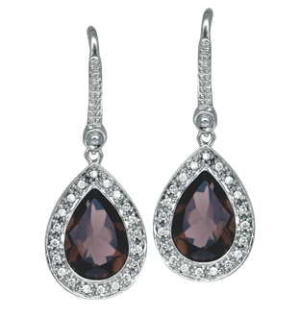

#25307

Vintage 14k white gold drop earrings   
set with 3.54 carats   
of smoky quartz & diamonds.  
Retail Price: $1,575,   
**Our Price: $1,295**

LEGEND  
k - karat

**Engagement Rings**

|  |  |  |
| --- | --- | --- |
| A close up of a ring  #25538  New 14k yellow gold cathedral engagement ring set with a 2.00 carat  lab-grown diamond.  Retail Price: $3,350,  **Our Price: $2,895** | A close up of a ring  #26083  New 14k yellow gold wedding set centered with a 4.12 carat lab-grown diamond surrounded by a 0.38 carat lab-grown diamond under hole.  Retail Price: $9,285,  **Our Price: $7,900** | A close up of a ring  #25539  New 14k white gold engagement ring set with a 3.02 carat lab-grown diamond & 0.37 carats of lab-grown diamonds.  Retail Price: $4,595,  **Our Price: $3,950** |
| A close up of a diamond ring  #26085 New 14k white gold 3-stone engagement ring centered with a 5.00 carat lab-grown diamond flanked by  1.60 carats of lab-grown diamonds.  Retail Price: $12,050,  **Our Price: $9,995** | A diamond ring with a diamond in the middle  #26086  New 14k white gold engagement ring centered with a 4.02 carat lab-grown diamond surrounded by a 0.50 carat lab-grown diamond under-halo.  Retail Price: $9,295,  **Our Price: $7,950** | **A close up of a ring**  #21746 Vintage 14k white gold Neil Lane engagement ring set with a 0.65 carat diamond & 0.30 carats of diamonds in the band & matching wedding band.  Retail Price: $4,000,  **Our Price: $2,200** |
| A close-up of a diamond ring  #25506  Vintage platinum engagement ring centered with a 1.04 carat diamond surrounded by a 0.23 carat diamond halo.  Retail Price: $6,250,  **Our Price: $4,995** | A diamond ring with a black background  #24843 Vintage 14k white & rose gold engagement ring set centered with a 0.38 carat diamond plus  0.95 carats of diamonds in the double halo & matching wedding band.  Retail Price: $2,550,  **Our Price: $1,850** | A diamond ring with a black background  #23040 Vintage 14k white gold Vera Wang engagement ring set with a 0.80 carat diamond, plus 0.41 carats of diamonds & sapphires.  Retail Price: $3,250,  **Our Price: $2,600** |

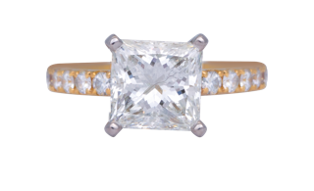

#23055  
Vintage 14k yellow gold engagement   
ring set with a 2.03 carat diamond &   
0.32 carats of diamonds.   
Retail Price: $17,500,   
**Our Price: $12,500**

LEGEND  
k - karat

**Lab-Grown Gemstone Jewelry**

|  |  |  |
| --- | --- | --- |
| **A close up of a diamondA close up of a diamond**  #24740  New 14k white gold flower earrings set with 0.43 carats of lab-grown diamonds.  Retail Price: $925,  **Our Price: $795** | **A close-up of a pair of scalpels**  #25057  New 14k white Chatham gold bangle bracelet set with a  1.70 carat lab-grown emerald &  1.27 carats of lab-grown diamonds.  **Price: $4,950** | **A close-up of a ring**  #24693  New 14k white gold Chatham ring set with a 2.60 carat  lab-grown ruby & 0.35 carats of lab-grown diamonds.  **Price: $2,925** |
| **A close up of a ring**  #25081  New 14k white gold Chatham 3-stone ring centered with a 1.61 carat lab-grown aqua spinel flanked by 0.48 carats of lab-grown diamonds.  **Price: $1,995** | **A close-up of a bracelet**  #25536  New 14k yellow gold tennis bracelet set with 5.12 carats of lab-grown diamonds.  Retail Price: $5,575,  **Our Price: $4,750** | **A close-up of a necklace**  #25055  New 18k white gold  Chatham pendant set with a 3.61 carat lab-grown chrysoberyl & 0.84 carats  of lab-grown diamonds.  **Price: $3,275** |
| **A close-up of a diamond necklace**  #18867  New 14k white gold solitaire pendant set  with a 1.99 carat  lab-grown diamond.  Retail Price: $2,495,  **Our Price: $2,195** | **A pair of diamond stud earrings**  #24722  New 14k white gold cluster ring set with 0.97 carats of lab-grown diamonds.  Retail Price: $1,325,  **Our Price: $1,225** | **A pair of diamond earrings**  #25302  New 14k white gold stud earrings set with  1.50 carats of lab-grown diamonds.  Retail Price: $1,050,  **Our Price: $935** |

LEGEND  
k - karat

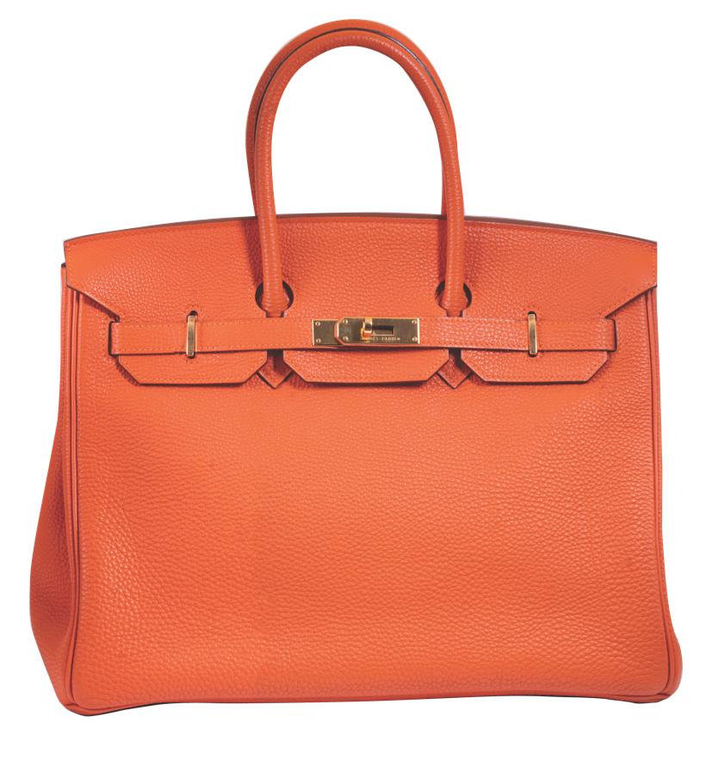**Vintage Designer Jewelry   
& Handbags**

|  |  |  |
| --- | --- | --- |
| **A silver circular object with holes**  #24564  Vintage 18k white gold Cartier *Love* ring.  Retail Price: $2,080,  **Our Price: $1,350** | **Close-up of a beaded necklace**  #24873  Vintage sterling silver Tiffany & Co. *Paloma Picasso* multi-gemstone bracelet.  Retail Price: $1,000,  **Our Price: $650** | **A pair of earrings with a yellow stone**  #24324  Vintage sterling silver &  18k yellow gold David Yurman *Albion* clip-on earrings set with  lemon quartz.  Retail Price: $1,300,  **Our Price: $600** |
| **A silver necklace with diamonds**  #25732  Vintage 18k white gold  Tiffany & Co. *Smile* pendant set with  0.03 carats of diamonds.  Retail Price: $1,925,  **Our Price: $1,195** | **A brown leather book with gold logoA close up of a necklace**  #25469  Vintage 18k rose gold Tiffany & Co. *Elsa Peretti Open Heart* necklace set with 1.15 carats of diamonds.  Retail Price: $17,000,  **Our Price: $9,950** | #24516  Vintage brown  leather  Louis Vuitton  *Monogram*  bi-fold wallet.  Retail Price: $500,  **Our Price: $350** |
| #24888  Hermes *Birkin 35 Togo* handbag with dust bag & box.  Retail Price: $12,700,  **Our Price: $10,700** |  | **A brown leather book with gold logo** |

LEGEND  
k - karat

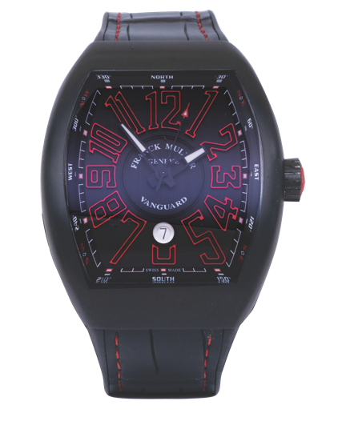**New & Pre-owned Watches**

|  |  |  |
| --- | --- | --- |
| A close-up of a watch  #25464  Pre-owned Cartier *Tank Francaise* watch with a pink mother-of-pearl dial. 20mm. 18KR & SS, C, F, Q.  Retail Price: $6,000,  **Our Price: $4,150** | A gold watch with red face and diamonds  #25281  Pre-owned Rolex *Datejust President* watch with a red diamond dial. 26mm. 18KY, A, B, C, F, Pr.  Retail Price: $32,200,  **Our Price: $10,500** | A close-up of a watch  #25282  Pre-owned Rolex *Datejust* watch with a black dial. 36mm. SS, A, C, F, O.  **Price: $7,550** |
| **A close-up of a watch**    #25621  Pre-owned Tissot *Seastar 1000* watch with rotating bezel. 36mm. SS, C, F, Q.  Retail Price: $450,  **Our Price: $285** | A close-up of a watch  #24981  Pre-owned IWC  *Portuguese Chrono Rattrapante* watch with a silver dial. 40mm.  SS, A, C, L.  Retail Price: $8,550,  **Our Price: $5,150** | A close up of a watch  #24781  New Hamilton *Jazzmaster Open Heart* watch with an exhibition case back. 42mm. SS, A, B, C, L, T.  **Price: $1,075** |

|  |  |
| --- | --- |
| A silver watch with a silver band  #24984 Pre-owned TAG Heuer *Grand Carrera* watch with an exhibition case back. 43mm. SS, A, C, F. Retail Price: $7,350,  **Our Price: $3,550** | #25574  Pre-owned Franck Muller *Vanguard Krypton* watch with a black dial. 44mm.  Ti, A, B, C, F, L.  Retail Price: $9,400,  **Our Price: $7,250** |

Legend  
18KY – 18k yellow gold  
18KR – 18k rose gold  
A – automatic movement  
B – box and/or papers  
C – sapphire crystal  
F – folding clasp  
L – leather bracelet  
O – Oyster bracelet  
Pr – President bracelet  
Q – quartz movement  
SS – stainless steel   
T – tang buckle  
Ti – titanium

**Extraordinary Antique Deals**

|  |  |  |
| --- | --- | --- |
| **A close-up of a ring**  #26168  Antique platinum ring centered with a 0.51 carat old European cut diamond set in carved quartz and surrounded by 0.45 carats of diamonds.  Retail Price: $3,200,  **Our Price: $2,650** | **A silver crown with diamonds**  **A silver crown with diamonds**  #20561  Antique platinum hinged bangle bracelet set with 1.25 carats of old European cut diamonds.  Retail Price: $4,075,  **Our Price: $3,450** | **A close-up of a necklace**  #26004  Antique Edwardian platinum dangle pendant set with 3.05 carats of old European cut diamonds.  Retail Price: $6,850,  **Our Price: $5,850** |